Sussex’s Wasted Brownfield Land the Size of a Large Town
The total area of unused brownfield land in Sussex is approximately the size of Littlehampton in West Sussex or Bexhill in East Sussex, according to new figures released today by the Countryside Charity, CPRE Sussex.
The charity’s ‘State of Brownfield Report 2020’ shows that there are 1,007 acres of abandoned brownfield sites in Sussex. That is enough to build at least 23,000 new homes on land which could be developed in preference to building on the countryside. This is the equivalent of a large town (with an average of 2.2 people per household).
These brownfield sites would provide enough development land to satisfy Sussex’s entire current Local Plan housing requirement for the next three and a half years (or for nearly 2 years under the government’s proposed changes to the housing calculations).
“It’s a travesty that so much brownfield land, in need of regeneration and revival, is lying idle whilst our green spaces which are vital for wildlife and our wellbeing are being lost to concrete,” says CPRE Sussex Director, Kia Trainor.
“The system needs to change so that brownfield land is revitalized before we lose any more of the countryside which is even more important at this time of climate and ecological emergency.”
The area with the most brownfield in Sussex is Brighton and Hove which has a total of 185 acres of brownfield spread over 172 sites. This is enough for more than 9,000 dwellings.
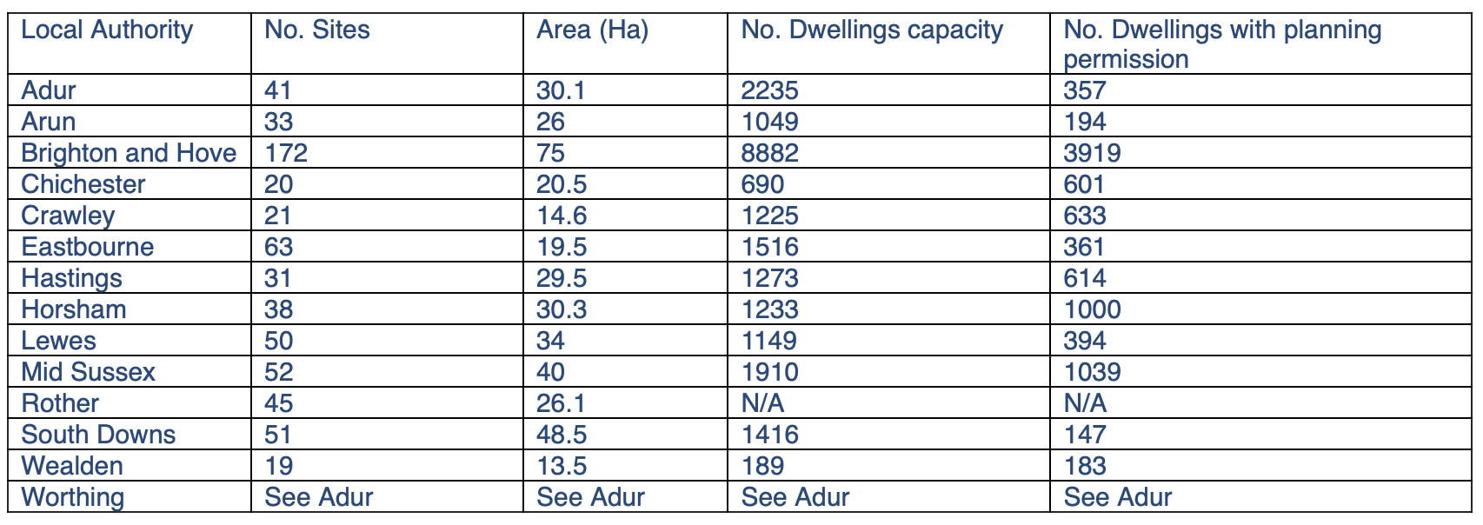
*Please note these figures do not include small sites
Nationally, the new report shows that there is enough brownfield land for 1.3 million new homes and over half a million already have planning permission.
The figures demonstrate that there is already enough land available in England to meet the government’s ambition to build 300,000 homes per year for the next 5 years (from the middle of the decade), calling into question the controversial plans to deregulate the planning system that has been proposed by ministers.
Commenting on the latest figures, Crispin Truman, chief executive of CPRE, the countryside charity, said:
“Today’s figures clearly show that the planning system is not what is ailing our housing market. If there is enough land in the planning system to meet the government’s own housing targets, what will an overhaul of the planning system, with rushed and untested changes, really achieve?”
“It’s clear the government have gravely misdiagnosed the problem – slow build-out rates and market-led housing are blocking the quality affordable housing that rural communities are crying out for.”
For More Comment Please Contact:
CPRE Sussex Director, Kia Trainer: 07964 894333
For Further analysis of the figures please contact:
CPRE Sussex’s Nick Daines on 07923 464836
https://www.cpre.org.uk/resources/state-of-brownfield-2020/

