Proposal to plant [insert number] trees at [insert location]

Dear neighbour

We are [a group of local residents/insert specific group name] and we would like to see more trees planted in our area. Now we need your help.

Trees are incredibly important to neighbourhoods like ours. They improve our health and wellbeing, support wildlife, reduce air pollution and flooding, provide shade, regulate the microclimate, and help reduce our carbon footprint. We think they look beautiful too.

We have identified possible planting sites with help from Plant Your Postcode and the council’s Tree Planting team. Now all we need to do is raise the funds! The council has limited funds for replacing trees but not for planting new street trees. That is why we need your help.

Once we have raised the money, the council’s tree experts will help us chose trees with the ability to cope with coastal conditions and chalky soils. They will also help us pick varieties which will not damage nearby buildings, pavements or underground services. The trees will be planted and cared for by the council’s Tree Planting team.

We would like to hear from you about the project. Can you help us raise funds, spread the word, or become a tree champion? Is there a space on your street which needs a tree?

Turn over to see the proposed plan for tree planting in your area.
If you have any concerns, please be specific about which tree(s) you are referring to by quoting the unique tree code marked on the planting plan. Please respond by [insert date]

Planting and growing trees takes time but with your help we can make this happen.

If you would like to get involved in our project, or share feedback on the plans, get in touch by [insert best way for people to contact].

We look forward to hearing from you
[Insert organiser/s name/s]

Proposed plan for tree planting

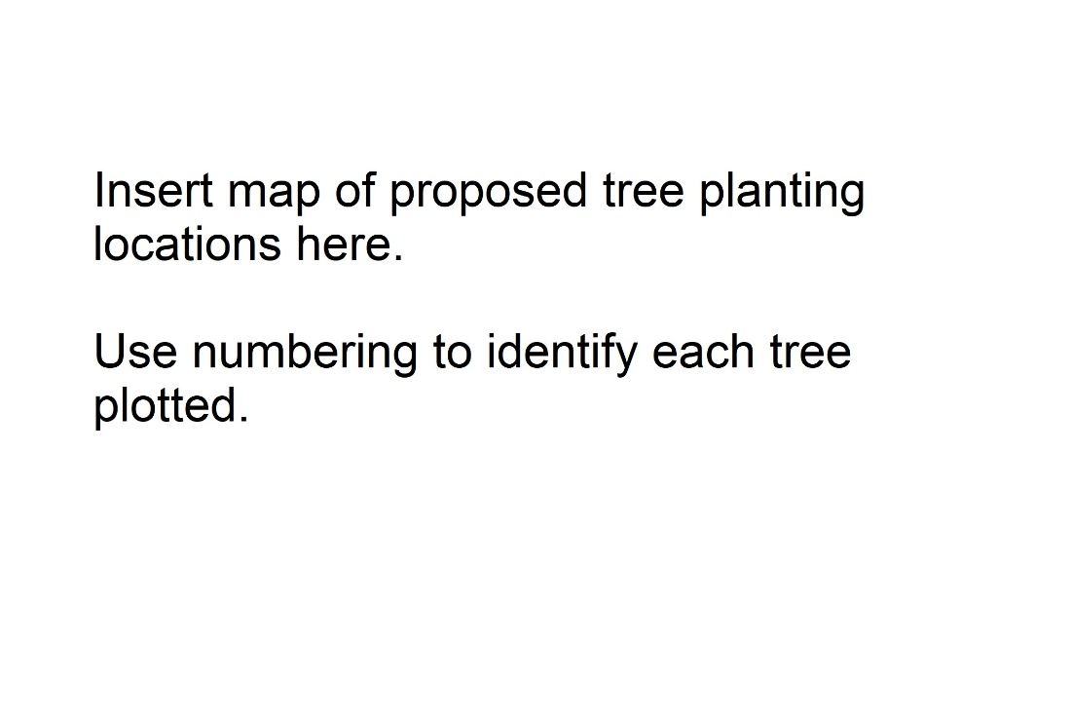

Before and after images
[If planting taking place in more than one street include as many images as necessary to illustrate]

